# Software Installation Instructions

1. Setting up Java on your Windows machine:
   1. Install Java from the below website:

<https://www.oracle.com/java/technologies/javase-jdk8-downloads.html>

* 1. Setting up Java Environment variables :
* Go to system properties
* Click on Advanced System settings

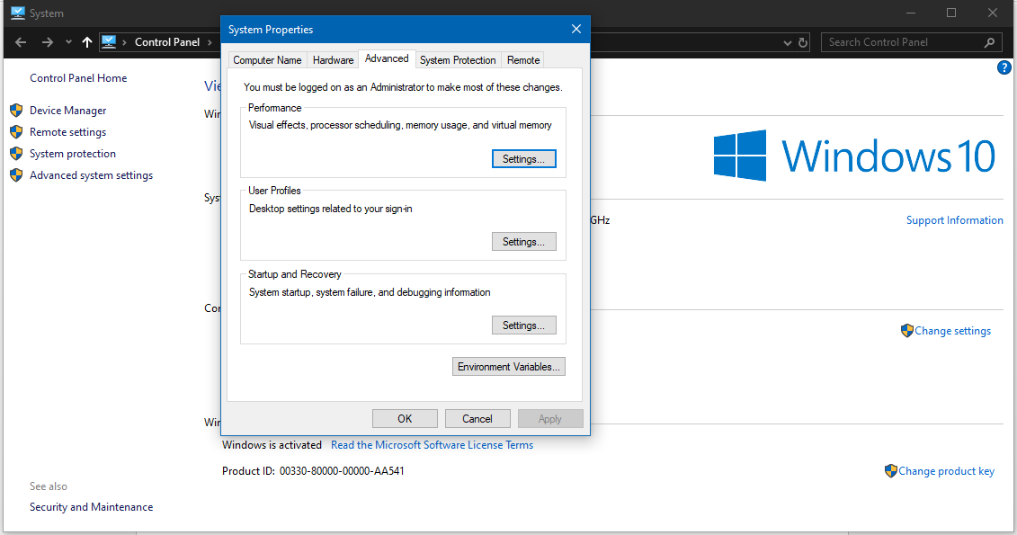

* Click on Environment Variables
* Click on “NEW” and set the JAVA_HOME
  + JAVA_HOME –
    - Name the variable “JAVA_HOME”
    - The “Variable Name” would be the path where jdk is installed
  + Click on OK

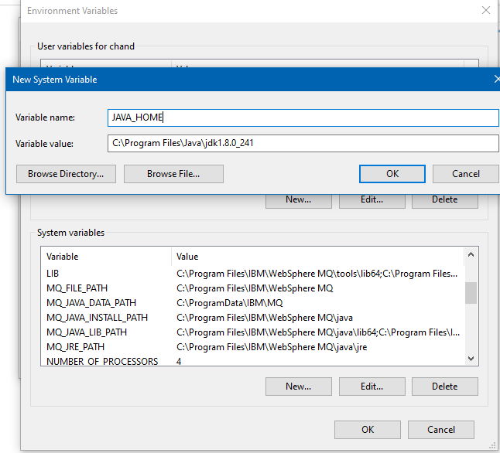

* When Path is not previously set :
  + Click on “NEW” and set the Path
    - Name the variable “Path”
    - The “Variable Name” would be the path where jdk/bin is installed
  + Click on OK

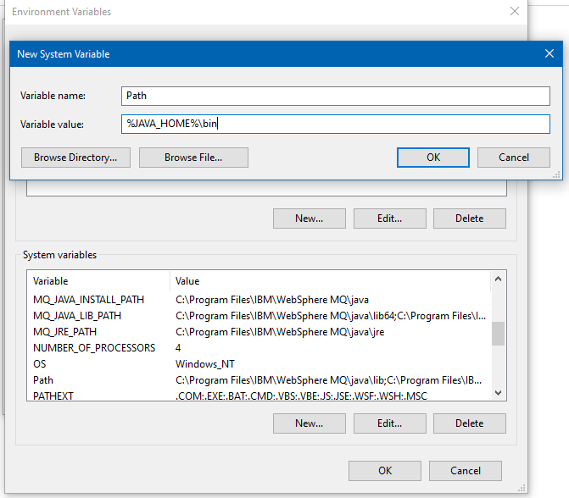

* When Path is previously set :
  + Click on “Edit” and add the java Path to the existing path
  + Click on New
  + Add the path to the jdk/bin folder
  + Click on OK
  1. Check if Java is set successfully
     + Open command prompt
     + Type “ java -version”, you should see the java version on the command prompt

1. Install Eclipse IDE from the below website:

<https://www.eclipse.org/downloads/packages/>

1. Install the following from Eclipse Marketplace:
   1. Cucumber Plugin

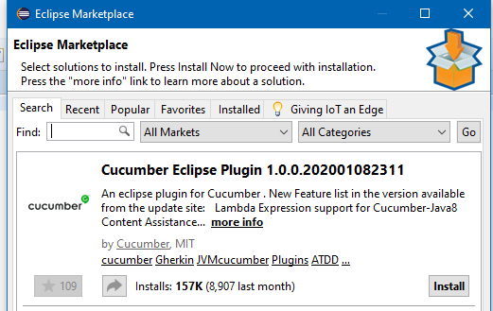

1. Download latest web drivers from the below website. Select the appropriate version for driver download based on your operating system:
   1. Chrome: <https://sites.google.com/a/chromium.org/chromedriver/downloads> (check the browser version and download the chrome driver accordingly)
2. All maven dependencies can be found in Maven Repository: <https://mvnrepository.com/>
3. Make sure Chrome browser is installed on your machine